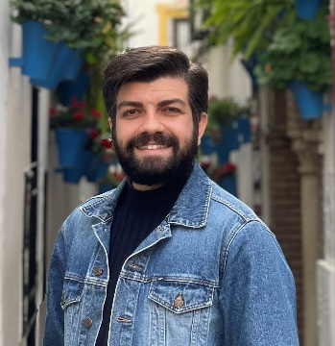
Assoc. Prof. Caner YEDİKARDEŞ (Samsun, 1988)
Education: 2011: Completed his undergraduate studies in the Ceramic Department of Hacettepe University Faculty of Fine Arts. 2014: Completed his master's degree at Hacettepe University Institute of Fine Arts. 2018: Successfully completed his proficiency in art education at Hacettepe University Institute of Fine Arts.
Academic Career: 2014-2018: Taught Visual Arts Education courses at Ankara University Faculty of Educational Sciences. 2016-2018: Instructed Ceramic and Stained Glass Application courses at Çankaya University and Hacettepe University's Elective Courses Unit. 2018-2022: Served as an Assistant Professor at the Ceramic Department of Atatürk University Faculty of Fine Arts and actively took on the role of Deputy Department Chair. Currently, he works as an Associate Professor at Hacı Bayram Veli University Faculty of Art and Design, Ceramic Design Department.
Personal Artistic/Scientific Works: In 2019, he developed a 3D model called "Test Tube Storage Stand" as an example of industrial design to be used in hospitals and applied for Turkish Patent with a BAP (Scientific Research Projects) Intellectual Property Project. In 2019, to raise environmental awareness about the threat of "Drought," he organized exhibitions at Ankara Rahmi Koç Museum and the General Directorate of State Hydraulic Works (DSİ). One artwork from each institution's exhibition is permanently displayed. Additionally, one artwork from the exhibition is also featured in the newly established Erzurum Ispir Art Museum. In 2020, during the pandemic, he held an exhibition titled "Probation" at Erzurum State Painting and Sculpture Museum to draw attention to mask usage. In 2021, he executed a project called "Smithereens" combining "Ice and Ceramic," which was an original work of mixed techniques and materials, first exhibited at Ata Ice Art Museum and later at Art Ankara Contemporary Art Fair.
International Experiences: In 2013, he served as an Invited Artist in South Korea, participating in museum establishment and kiln construction processes. In 2014, within the scope of the "The Place of Italian Buildings with Sculptures and Paintings Inside in Socio-Political Transmission" project, he participated in a cultural trip to Italy with the Hacettepe University Plastic Arts Society. In 2021-2022, he undertook Erasmus+ Teaching Mobility in Poland and Spain.
Academic Research and Projects: He currently has 4 ongoing BAP (Scientific Research Projects) applications, 18 published articles, papers, and book chapters."

